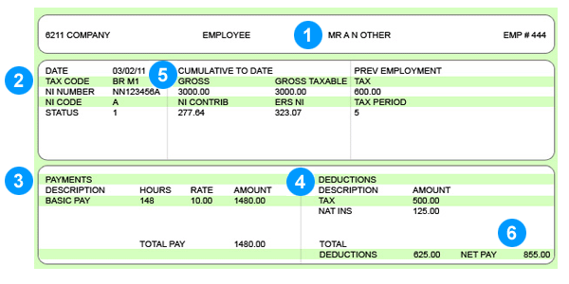

What does this mean?

- Your personal information  Your name and permanent home address will be shown here. If you're on long-term sick leave, for example, this means that you should still usually be able to receive your payslip.  - Tax code and National Insurance number  Your tax code is given to you by the Inland Revenue - it tells your employers how much tax to deduct from your pay. If you have the wrong tax code you could end up paying too much or too little tax.  Your National Insurance (NI) number is also usually shown on your payslip. You have to have a NI number to work in the UK, and it stays the same for your whole life, even if you move abroad or change your name. Your NI number is like your personal account number for the whole social security system. It makes sure your National Insurance contributions and the tax you pay are properly recorded on your account. You pay National Insurance contributions to build up your entitlement to certain state benefits, including the State Pension. The contributions are taken automatically from your pay (unless you are self-employed).  - Payments - wages, bonuses, etc.  This section shows the amount of your wages before any deductions (gross wages), like tax, pension or national insurance contributions. It might also show a breakdown of how your pay was calculated - maybe an hourly or weekly rate multiplied by the number of those hours or weeks you've worked. It could also show any bonuses or commission you've earned. | - Deductions - taxes, pension, etc.  Your payslip must show the amount of any fixed deductions (such as trade union subscriptions). It'll also show individual amount of any variable deductions, like tax, National Insurance and pension contributions, which have been made from your pay.  - Year to date  Usually, you'll see a section that shows how much you've been paid so far in the financial year (6 April one year to 5 April the next year). It'll probably how much tax you've paid so far in the year, and the amount of National Insurance contributions both you and your employer have made.  You may also have a section called 'Pay this period', which'll show you a breakdown of how you've been for the period that your payslip covers. That means it might be weekly or monthly.  - Net pay - what's left  Your payslip will show your take-home pay for this period: the net amount of your wages. This is the total after deductions like tax have been made. You can check this against your bank statement to make sure they're the same amounts.

What about my tax code?
Your tax code is usually made up of several numbers and a letter, such as 647L. If your tax code is a number followed by a letter, times the number by 10 and you’ll get the total amount of income you can earn in a year before paying tax. In this case, that’s 647 x 10 = £6,470. If you earn £10,000, you won’t pay tax on at least £6,470 of it. The letter’s connected to your personal circumstances, such as your age and whether you have two jobs. A lot of people are on a 647L code, but there are other common ones too. If you start working a second job or your pay changes suddenly, tell the tax office. If you think you might not be on the right tax code, you can visit the HM Revenue and Customs website to find out more at www.hmrc.gov.uk/incometax/codes-basics.htm.
For example, if you were suddenly moved to a 117L code from a 647L code, this would mean that your untaxed allowance has gone down. For a 117L code, you could earn only £1,170 before paying tax. Let’s say you’re earning £10,000 a year – look at the table below to compare the difference a code change could make to your earnings:

