Understand how to safeguard the wellbeing of
Children and Young People

Level 3 Playwork – Unit 1
Workbook for Learning Outcome 2

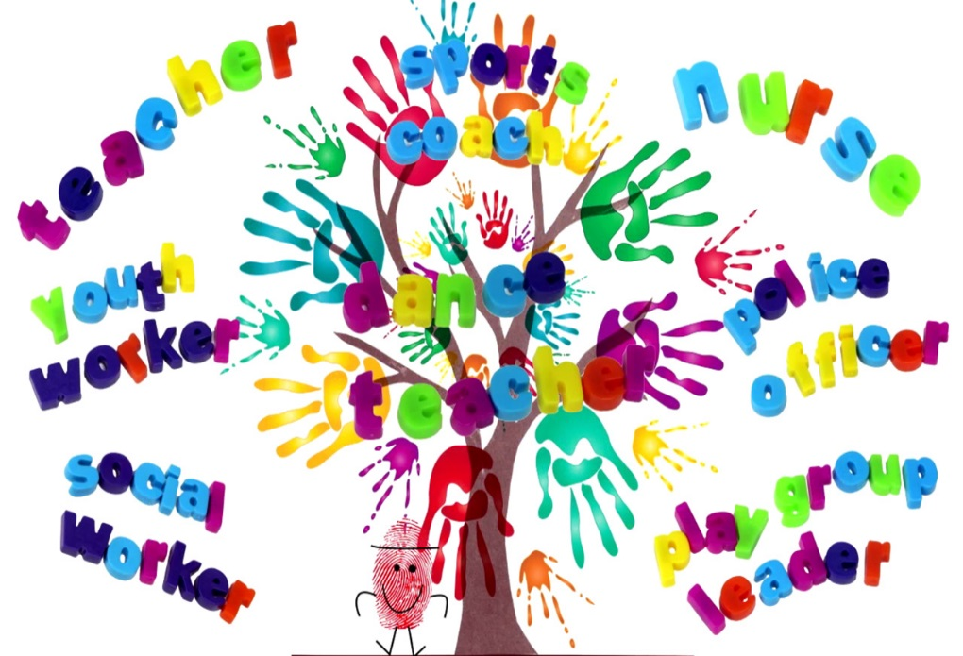

Name: ______________________________________

Date Submitted: ______________________________________

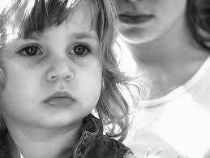
Introduction

The childcare sector places the well-being of children at the heart of all its services. Unfortunately some children and young people are exposed to dangers resulting from the words and actions of other people.

In this unit learners will gain an understanding of how the childcare sector aims to defend children and protect them from this kind of abuse, and how the sector is learning the lessons of past failures.

Learning outcomes: Unit 1 has seven learning outcomes:

This workbook is designed to support the assessment criteria for:

Learning Outcome 2:

Understand the importance of working in partnership with other organisations to safeguard children and young people

2.1 explain the importance of safeguarding children and young people

2.2 explain the importance of a child or young person-centred approach

2.3 explain what is meant by partnership working in the context of safeguarding

2.4 describe the roles and responsibilities of the different organisations that may be involved when a child or young person has been abused or harmed

Complete each of the task shown and then utilise the notes collected to prepare for a professional discussion with your allocated Teaching and Learning Coordinator
The importance of safeguarding 2.1 & 2.2
Task 1
Childcare qualifications have whole units or modules dedicated to safeguarding. Why do you think this area is given such prominence?

Task 2
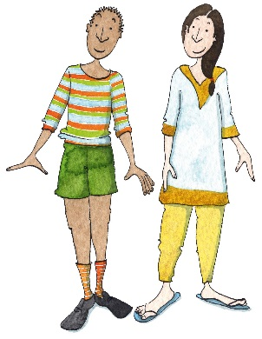
Complete the following spider diagram to illustrate the importance of a child- or young person-centred approach to safeguarding. One reason has already been completed for you.

Because the Children Act says the best interests of the child should be paramount

Working in partnership 2.3 & 2.4
Task 1
The Audit Commission describes partnership as a joint-working arrangement where the partners:
- are independent bodies
- cooperate to achieve a common goal
- create a new organisational structure or process to achieve this goal, separate from their own organisations
- plan and implement a jointly agreed programme, often with joint staff or resources
- share relevant information
- pool risks and rewards.
Source: www.idea.gov.uk
Explain how your setting covers partnership working in its policies and procedures for safeguarding children and young people. When your setting works in partnership with others, how well does the partnership match the description above?

Task 2
For each of the organisations listed below identify one key role that they have when a child or young person has been harmed or abused.
Police

Doctor’s surgery

Social services

School/nursery

NSPCC

Professional Discussion: Playwork – Level 3

Candidate |  | Units
Date |  | Unit 1  Learning Outcome 2  2.1, 2.2, 2.3 & 2.4
Venue
Assessor
Supporting evidence is required for this assessment method. You may use video or audio recordings, as well as photographs and work products. | Evidence record no.

Recording time
L/O 2: Understand the importance of working in partnership with other organisations to safeguard children and young people

2.1 explain the importance of safeguarding children and young people
2.2 explain the importance of a child or young person-centred approach
2.3 explain what is meant by partnership working in the context of safeguarding
2.4 describe the roles and responsibilities of the different organisations that may be involved when a
child or young person has been abused or harmed

