Understand how to safeguard the wellbeing of
Children and Young People

Level 3 Playwork – Unit 1
Workbook for Learning Outcomes 4 and 5

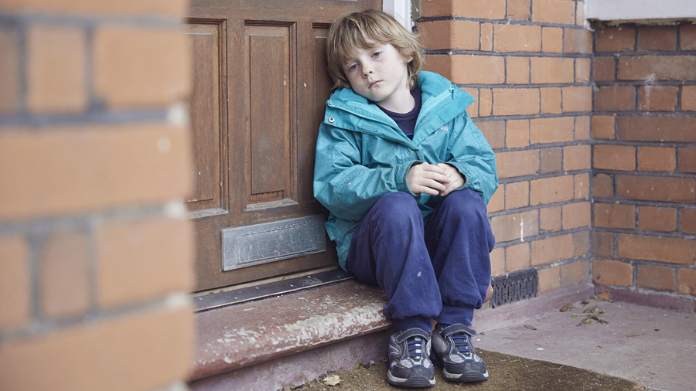

Name: ______________________________________

Date Submitted: ______________________________________

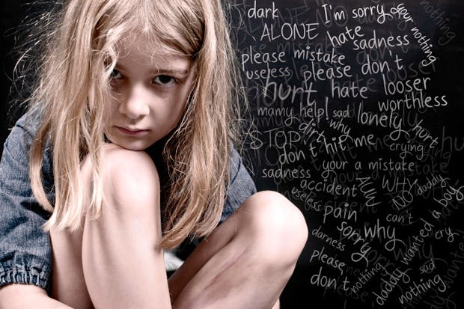

Introduction

The childcare sector places the well-being of children at the heart of all its services. Unfortunately some children and young people are exposed to dangers resulting from the words and actions of other people.
In this unit learners will gain an understanding of how the childcare sector aims to defend children and protect them from this kind of abuse, and how the sector is learning the lessons of past failures.

Learning outcomes: Unit 1 has seven learning outcomes:

This workbook is designed to support the assessment criteria for:

Learning Outcomes 4 and 5

L/O 4: Understand how to respond to evidence or concerns that a child or young person has been abused or harmed

4.1 describe the possible signs, symptoms, indicators and behaviours that may cause
concern in the context of safeguarding

4.2 describe the actions to take if a child or young person alleges harm or abuse in line
with policies and procedures of own setting

4.3 explain the rights that children, young people and their carers have in situations where harm or abuse is suspected or alleged

L/O 5: Understand how to respond to evidence or concerns that a child or young person has been bullied

5.1 explain different types of bullying and the potential effects on children and young people

5.2 outline the policies and procedures that should be followed in response to concerns or evidence of bullying and explain the reasons why they are in place

5.3 explain how to support a child or young person and/or their family when bullying is suspected or alleged

Complete each of the task shown and then utilise the notes collected to prepare for a professional discussion with your allocated Teaching and Learning Coordinator

Child abuse 4.2 & 4.3
Task 1
Case studies

Saskia has only recently joined your setting and seems withdrawn.
You go to the corner where she is sitting by herself and tell her you are going to read her a story.
As you settle yourself close to Saskia and open the book, she begins to cry and asks you not to hurt her.

How should you deal with Saskia’s reactions and comments?

Who should you inform about this incident?

Task 2
Look at the United Nations Convention on the Rights of the Child located on the FW Solutions Website
Identify which of the Articles relate to the rights of the child where harm or abuse is suspected or alleged and write the names of the Articles in the boxes below.

Bullying 5.1, 5.2 & 5.3
Task 1
On the spider diagram below, add the different types of bullying that a child or young person may experience. An example has been completed for you.

Verbal
Bullying

Task 2
What effects can bullying have on a child or young person?

Task 3
Case study

Ansa is the nursery manager of a small rural setting that has strong community links. A traveller group has settled in a field on the outskirts of the village and local residents are petitioning for them to be moved on.
Ella is nearly five and is the daughter of one of the traveller families. Within the first week that Ella joins the nursery, Ansa is aware that she is being excluded from activities and the children are displaying hostility towards her.
She overhears one child say to Ella ‘go away, we don’t want you here. My mummy says I mustn’t talk to you’. Ella bursts into tears and hides in the book corner.

1. What should Ansa do to resolve the situation?

2. How can Ansa support Ella and her family?

Professional Discussion: Playwork – Level 3

Candidate |  | Units
Date |  | Unit 1  Learning Outcome 4  4.1, 4.2 & 4.3
Venue
Assessor
Supporting evidence is required for this assessment method. You may use video or audio recordings, as well as photographs and work products. | Evidence record no.

Recording time
L/O 4: Understand how to respond to evidence or concerns that a child or young person has been abused or harmed

4.1 describe the possible signs, symptoms, indicators and behaviours that may cause concern in the
context of safeguarding
4.2 describe the actions to take if a child or young person alleges harm or abuse in line with policies
and procedures of own setting
4.3 explain the rights that children, young people and their carers have in situations where harm or
abuse is suspected or alleged

Professional Discussion: Playwork – Level 3

Candidate |  | Units
Date |  | Unit 1  Learning Outcome 5  5.1, 5.2 & 5.3
Venue
Assessor
Supporting evidence is required for this assessment method. You may use video or audio recordings, as well as photographs and work products. | Evidence record no.

Recording time
L/O 5: Understand how to respond to evidence or concerns that a child or young person has been bullied

5.1 explain different types of bullying and the potential effects on children and young people
5.2 outline the policies and procedures that should be followed in response to concerns or evidence of
bullying and explain the reasons why they are in place
5.3 explain how to support a child or young person and/or their family when bullying is suspected or alleged

