Understand how to safeguard the wellbeing of
Children and Young People

Level 3 Playwork – Unit 1
Workbook for Learning Outcome 7

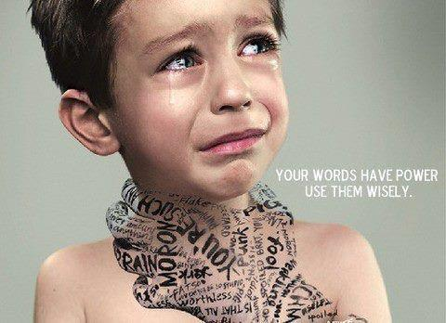

Name: ______________________________________

Date Submitted: ______________________________________

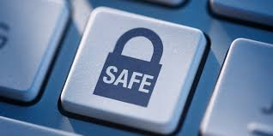
Introduction

The childcare sector places the well-being of children at the heart of all its services. Unfortunately some children and young people are exposed to dangers resulting from the words and actions of other people.

In this unit learners will gain an understanding of how the childcare sector aims to defend children and protect them from this kind of abuse, and how the sector is learning the lessons of past failures.

Learning outcomes: Unit 1 has seven learning outcomes:

This workbook is designed to support the assessment criteria for:

Learning Outcome 7:

Understand the importance of e-safety for children and young people

7.1 explain the risks and possible consequences for children and young people of being online and of using a mobile phone

7.2 describe ways of reducing risk to children and young people from:

- social networking
- internet use
- buying online
- using a mobile phone.

Complete each of the task shown and then utilise the notes collected to prepare for a professional discussion with your allocated Teaching and Learning Coordinator

E-safety for children and young people: 7.1 & 7.2
While we all acknowledge that technology plays an important part in children and young people’s learning, it also has its dangers. Adults need to be aware of what these are and how they can give consideration to e-safety in their work with children and young people to minimise these risks.
In the table below, list the potential technological risks and suggest how practitioners could reduce them.
Potential technological risks | Ways of reducing potential technological risks to children and young people

Professional Discussion: Playwork – Level 3

Candidate |  | Units
Date |  | Unit 1  Learning Outcome 7  7.1 & 7.2
Venue
Assessor
Supporting evidence is required for this assessment method. You may use video or audio recordings, as well as photographs and work products. | Evidence record no.

Recording time
L/O 7: Understand the importance of e-safety for children and young people

7.1 explain the risks and possible consequences for children and young people of being online and of
using a mobile phone
7.2 describe ways of reducing risk to children
and young people from:

- social networking
- internet use
- buying online
- using a mobile phone.

