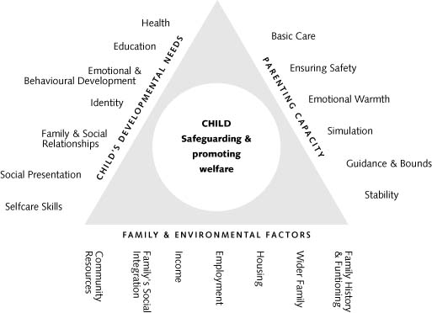
The Assessment Framework Triangle

Work with children and families should:

• be child centred - where there is a conflict of interest, decisions must be made in
the child’s best interests;
• be rooted in child development;
• be focused on outcomes for children;
• be holistic in approach – addressing the child’s needs within their family and wider
community;
• ensure equality of opportunity;
• involve children and families;
• build on strengths as well as identifying difficulties;
• be integrated in approach;
• be a continuing process not an event;
• provide and review services;
• be informed by evidence; and
• be transparent and open to challenge.

