‘s 5 LevelMaxwell’s 5 Levels of Leadership
http://www.leadershipnow.com/leadingblog/2011/10/maxwells_5_levels_of_leadershi.html

Maxwell's 5 Levels of Leadership
Over 30 years ago, John Maxwell began developing the 5 Levels of Leadership. It has been presented before but never to this depth and completeness. The 5 Levels express a way to understand and organize your leadership growth.
Each of the levels build on the previous one and you can only progress to the next level once you have mastered the previous level. As you go higher it is easier to lead because your influence grows as well, as your leadership becomes more service oriented. Maxwell says it takes longer than you think to get to the top level—and many never do. At the same time, you can go down very quickly. But if you have developed the right kinds of relationships with others, they will support you through your missteps and fumbles.
As shown below, the first level is POSITION. At this level, people follow you because they have to. Your influence comes from your position. While that’s not bad—you probably got the position because of your leadership potential—you don’t want to stay here. Leadership is about relationships and leaders will make it their business to develop them.
The second level is PERMISSION. People follow you because they want to. Permission is about building relationships. It focuses on the value of each person and opens up communication. Connecting with others begins with connecting with and growing yourself. Understanding that the first person I must get along with is me, the first person to cause me problems is me, the first person that must change is me, and the first person that can make a difference is me.
Level three – PRODUCTION – recognizes that relationships alone are not enough. A leader is tasked with getting things done. Production level leaders are followed because of what they have done for the organization. They get things done. Their credibility is based on their example. The ability to get results alone doesn’t make you a leader. Leaders are measured by what the entire group accomplishes and not by the individual efforts of the person in charge. Leaders develop their people into a team to get results. To get to the next level you must develop your people.
The fourth level is PEOPLE DEVELOPMENT. Leaders become great because they empower others. They develop more leaders. “Production may win games, but People Development wins championships.” People development assures that growth can be sustained. Self-centered, insecure leaders neglect this stage in their development.
Maxwell estimates that less than 1 percent of all leaders ever reach Level 5 – THEPINNACLE. Leaders at this level understand that the highest goal of leadership is to develop more leaders, not to gain followers or do work. Level 5 leaders develop Level 4 leaders. Developing leaders that can in turn develop leaders is hard work and takes a great deal of skill, focus, and a lifetime commitment. But those leaders that do create Level 5 organizations. They create opportunities that other leaders don’t. Level 5 leaders leverage their own leadership through others. People follow these leaders because of what they are and what they represent. “When you lead an organization, you can’t be focused on just fulfilling the vision or getting work done.”
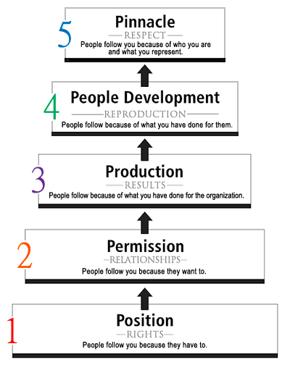
In addition to describing each of the Levels in detail, Maxwell shares upside and downside of each Level, how the 21 Irrefutable Laws of Leadership relate to each Level, an assessment to gauge your current level of leadership, and most practical, a growth guide to help you understand the mindset needed to move from one level to the next.

