The System Life Cycle (SLC)
The SYSTEM LIFE CYCLE is a process of stages which occur during the development of a new ICT or Admin system.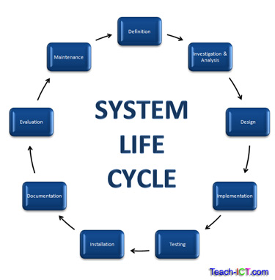
The SLC consists of the following stages:
- Definition
- Investigation and analysis
- Design
- Implementation
- Testing
- Installation
- Documentation
- Evaluation
- Maintenance
Although all projects should start with the definition stage and end with the maintenance stage, the process is not always completely linear. After completion of one stage, it might be necessary to return to an earlier stage.

