Discussion: Unfamiliar topic (Level 2)
How are “discount retailers” impacting on your local high street?

You have chosen to discuss how discount retailers impact on your local high street as your unfamiliar topic to meet the criteria for one of the tasks in your Functional Skills English qualification. You will be required to investigate this topic forming your own opinion on how you believe discount retailers are affecting your local area based on the research you have conducted. In order to prepare for your discussion you will conduct your own research to enable you to lead the discussion to a group of 3-5 people for approximately 5-10 minutes. Your Area Trainer will explain and plan this activity with you in more detail.

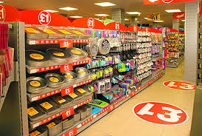
Introduction: You should start by introducing the topic by sharing any facts, statistics or information you have found relating to your topic. Something you may also want to consider and discuss is:

Do we really get a bargain at the £1 shop?
Research: You should plan your research and keep a note of any websites, news articles, you-tube footage etc. that you have used to help you form your own opinion.
Suggested Research Opportunities: You can get your research started by using some of the suggested materials below. However, this is your discussion so extend your research to help you gain a greater understanding of the topic.
Website
Finance News: https://uk.finance.yahoo.com/news/how-pound-shops-make-money.html
Finance News: https://uk.finance.yahoo.com/news/poundland-cuts-prices-93p-battle-152306895.html
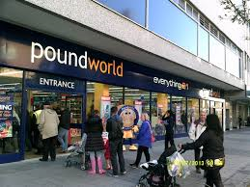
The Telegraph on-Line: http://www.telegraph.co.uk/finance/newsbysector/retailandconsumer/9543609/How-Poundland-makes-its-millions.html
BBC News: http://www.bbc.co.uk/news/uk-26881033
Daily Mail on-line: http://www.dailymail.co.uk/news/article-2124263/Discount-stores-thrive-recession-thrifty-seek-bargains.html
This is money: http://www.thisismoney.co.uk/money/news/article-2996781/High-Street-shop-closures-triple-mobile-phone-stores-fashion-retailers-biggest-victims-shows-study.html

News Papers – look out for articles relating to topic in local and national newspapers

