Discussion: Unfamiliar topic (Level 2)
Street lights turned off in their thousands to meet carbon emission targets - are you for or against this practice?

You have chosen to discuss street lights being turned off to meet carbon emissions as your unfamiliar topic to meet the criteria for one of the tasks in your Functional Skills English qualification. You will be required to investigate this topic forming your own opinion to share and discuss with the group. In order to prepare for your discussion you will plan to conduct your own research to enable you to lead the discussion to a group of 3-5 people for approximately 5-10 minutes. Your Area Trainer will explain and plan this activity with you in more detail.

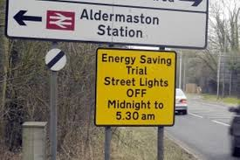
Introduction: You should start by introducing the topic maybe sharing what you have found by discussing if you are for or against streets lights being turned off. You will collect and share evidence to support your argument. Something you may also want to consider and discuss is:

Does the practice of switching off street lights increase the possibility of crime?

Research: You should plan your research and keep a note of any websites, news articles, you-tube footage etc. that you have used to help you form your own opinion.
Suggested Research Opportunities: You can get your research started by using some of the suggested materials below. However, this is your discussion so extend your research to help you gain a greater understanding of the topic.
Website
BBC News: http://www.bbc.co.uk/news/uk-politics-30569215
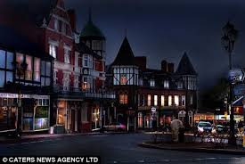
The Telegraph on-line: http://www.telegraph.co.uk/news/politics/council-spending/11306827/Three-quarters-of-councils-are-switching-off-or-dimming-streetlights.html
The Daily Mail on-line: http://www.dailymail.co.uk/news/article-2609277/Switching-street-lights-save-money-led-big-rise-injuries-fatalities-according-new-figures.html
The Telegraph on-line: http://www.telegraph.co.uk/news/9637929/Street-lights-turned-off-in-their-thousands-to-meet-carbon-emission-targets.html
Council Information: http://www.rctcbc.gov.uk/en/transportstreets/roads,highwaysandpavements/streetlighting-part-nightlighting/streetlighting-part-nightlightingfaqs.aspx
Tip: Check your local council website to see what their plans are for reducing light in your area
News Papers – look out for articles relating to The European Union in all of the national newspaper

