Discussion: Unfamiliar topic (Level 2)
What would happen if Britain left the European Union?

You have chosen to discuss how Britain would be affected if they left the European Union as your unfamiliar topic to meet the criteria for one of the tasks in your Functional Skills English qualification. You will be required to investigate this topic forming your own opinion of whether Britain should leave European Market based on the research you have conducted. In order to prepare for your discussion you will plan to conduct your own research to enable you to lead the discussion to a group of 3-5 people for approximately 5-10 minutes. Your Area Trainer will explain and plan this activity with you in more detail.

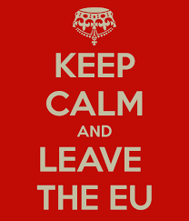
Introduction: You should start by introducing the topic maybe sharing what you have found by discussing if you are for or against leaving the European Union. You will collect and share evidence to support your argument. Something you may also want to consider and discuss is:

What affect did your research have on your final opinion?
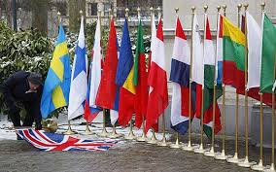
Research: You should plan your research and keep a note of any websites, news articles, you-tube footage etc. that you have used to help you form your own opinion.

Suggested Research Opportunities: You can get your research started by using some of the suggested materials below. However, this is your discussion so extend your research to help you gain a greater understanding of the topic.
Website
The guardian on-line: http://www.theguardian.com/politics/2015/apr/19/what-would-happen-if-britain-left-the-eu-consequences-of-exit

Better off out: http://www.betteroffout.net/the-case/10-eu-myths-about-withdrawl/
BBC News Round, the EU explained: http://news.bbc.co.uk/cbbcnews/hi/find_out/guides/european_union/newsid_2949000/2949880.stm
Video Footage: David Cameron discussing “What could happen if Britain left the EU? Five key issues” http://www.telegraph.co.uk/news/worldnews/europe/eu/11620807/What-could-happen-if-Britain-left-the-EU-Five-key-issues.html
News Papers – look out for articles relating to The European Union in all of the national newspaper

