

Report Writing Guide

This short guide is intended to support learners in the use of MS Word to present detailed reports.

The definition “Report” is to give a spoken or written account of something that one has observed, heard, done, or investigated.

When providing evidence to meet the requirements of “assignment briefs”, you may encounter a range of command verbs that ask you to:

**Analyse:**

Break an issue into its constituent parts. Look in depth at each part using supporting arguments and evidence for and against as well as how these interrelate to one another

**Compare:**

Identify the similarities and differences between two or more phenomena. Say if any of the shared similarities or differences are more important than others. ‘Compare’ and ‘contrast’ will often feature together in an essay question.

**Critically evaluate:**

Give your verdict as to what extent a statement or findings within a piece of research are true, or to what extent you agree with them. Provide evidence taken from a wide range of sources which both agree with *and* contradict an argument. Come to a final conclusion, basing your decision on what you judge to be the most important factors and justify how you have made your choice.

**Demonstrate:**

Show how, with examples to illustrate

**Describe:**

Provide a detailed explanation as to how and why something happens

**Explain:**

Clarify a topic by giving a detailed account as to how and why it occurs, or what is meant by the use of this term in a particular context. Your writing should have clarity so that complex procedures or sequences of events can be understood, defining key terms where appropriate, and be substantiated with relevant research.

**Outline:**

Convey the main points placing emphasis on global structures and interrelationships rather than minute detail.

**Summarise:**

Give a condensed version drawing out the main facts and omit superfluous information. Brief or general examples will normally suffice for this kind of answer.

These and others are some of the ways in which you are asked to provide evidence for formal assessment and feedback.

To be able to meet these requirements, it is important that you are able to set up the document used by you in the correct manner. It is important that you are able to incorporate relevant information, be this in word form, tabular form, incorporating graphs, charts or pictures and that you are able to format them to meet the required standards.

1. **Cover / Front Pages**

Once you have begun to develop information for presentation, it is important that you do this in a way that will benefit you and enable your assessor to read and understand more easily

Most reports begin with a front page, similar to the one on this guide. It is important to remember that you are providing evidence for assessment and not a poster depicting your ability to fill a page with pictures.

Remember to include a Title. Include details of the unit being met and include your name and the date of the assignment/report

1. **Inserting Pages**

If you wish to insert a page, most people simply let the text warp onto the next page. This is OK and allows a continuation of the last page. By allowing this the next page will appear the same as the last, if you are working on a page set up in “Portrait” the next page will appear in the same format. This is the same if working in “Landscape”

Sometimes when wanting to insert a table to demonstrate findings a portrait format does not allow sufficient room for text. In this instance, you may wish to insert a new page in a differing format.

Here is an example

1. Choose the “Page Layout” tab on your toolbar

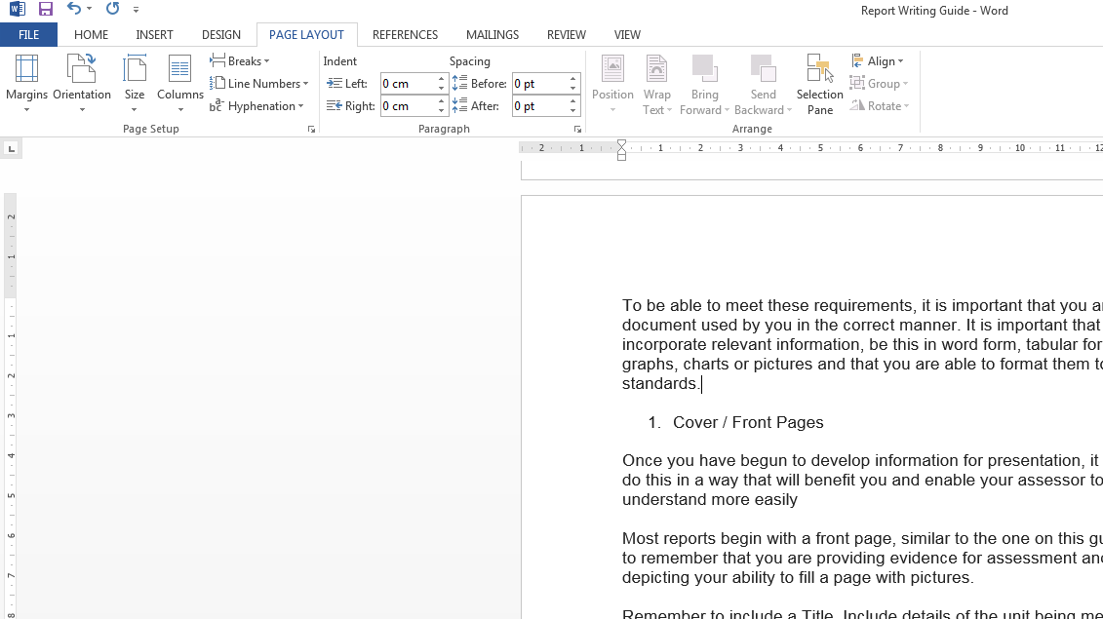

Then choose the “breaks” option



From the pull down menu, please choose the “Next Page” option

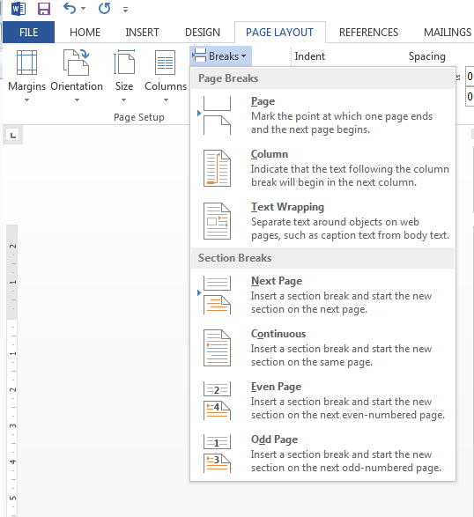

Once you have clicked on this option, it will automatically insert a new page. This will be in the same format as the previous page, portrait or landscape. To change the layout format, simply select the orientation tab and this will alter the selected page. This process can be repeated to meet the writer’s requirements

1. **Inserting Tables**

If you wish to present information in tabular form you will be required to insert the table and then format it to your requirements.

To insert a table, simply select the page and page layout you will require and follow these steps:

* From your toolbar at the top of the page select “Insert”
* Simply select the “Table” option
* Select the amount of Rows and Columns required
* These will appear on the sheet as required
* Simply click your mouse to end this process.

1. **Formatting Tables**

Once you have the selected amount of rows and columns, you may wish to format your table to meet your requirements. This can be done as follows

* Highlight the areas you wish to work with

|  |  |  |
| --- | --- | --- |
|  |  |  |
|  |  |  |
|  |  |  |

* In Table Tools, this will appear on your toolbar
* Select the “Layout” Option, this will allow multi-choice options
* Select the one you want such as merge cells

The following page shows how a new page may be added, the layout format changed and a table can be inserted to meet the writer’s needs

|  |  |  |  |  |  |
| --- | --- | --- | --- | --- | --- |
| Personal development plan for: AN Other | | | | | |
| ***Specific*** | ***Measurable*** | ***Achievable*** | ***Realistic*** | ***Timebound*** | ***Action Plan*** |
|  |  |  |  |  |  |
|  |  |  |  |  |
|  |  |  |  |  |
|  |  |  |  |  |

SMART Targets

1. **Inserting Images**

Some reports may require you to insert images of varying kinds. This may be a logo, a picture of a product or a chart or graph.

To do this you simply have to determine at what point to wish to enter the image, how you want it to appear and how you can explain the relevance of it.

To insert a “Picture” it is always best practice to have selected this and saved it into a specific folder with an appropriate filename. To select the required image simply follow these instructions:

* Select “Insert” from your toolbar at the top of the page
* Choose the “Picture” Icon
* Select the required folder and picture and click insert
* 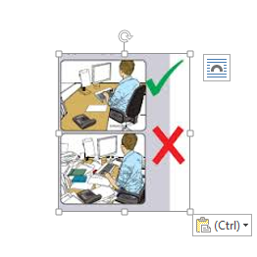The picture will appear somewhere on the page
* To format and move the picture, right click in it
* This image will appear showing the format Icon
* Click the Icon and a choice menu will appear

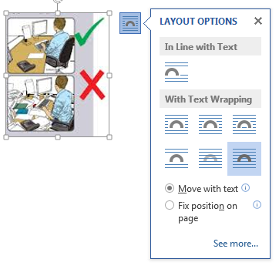

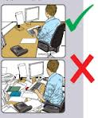

Once you have chosen your requirements, the picture can be positioned accordingly

This same principle applies to graphs and charts. Please try inserting these in your own work.

Please remember Reports and work submissions are designed to meet a purpose and this usually means informing the reader of fact and opinion. They should remain professional looking and not erratic.

Choose layouts wisely.