

Dyslexia Support

Changing MS Word Documents backgrounds

When working with any learner who has, or feels they have dyslexia, we must try to establish their individual preferences and display words documents accordingly

This may mean changes the font or the document appearance. When selecting appropriate fonts most of the recommendations come from associations for people with dyslexia and they agree in using sans-serif fonts. The British Dyslexia Association recommends to use **Arial**, **Comic Sans** or, as alternatives to these, **Verdana**, **Tahoma**, **Century Gothic, and Trebuchet.**

If you require to change a font, the simplest way is simply to highlight the section required

As below:

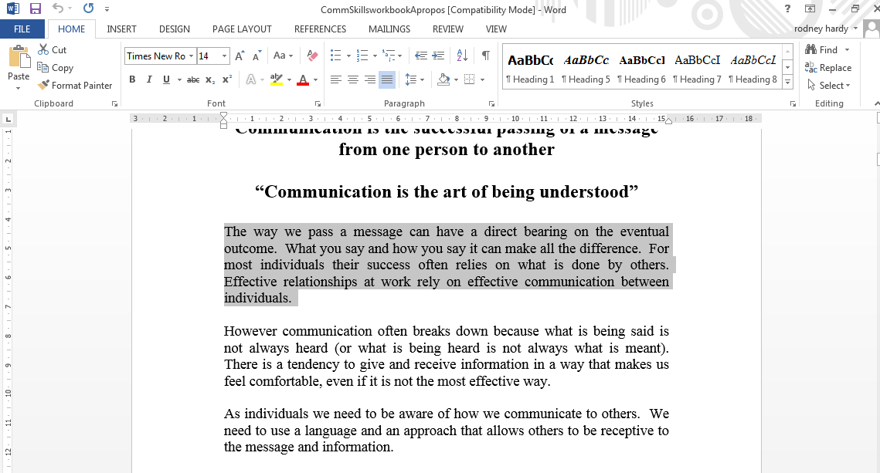

The only way I know is:

1. Open the required document
2. Click on the “Design Tab”
3. Choose the “Page Colour” Option
4. Set the page being viewed to any colour

Select the font required:

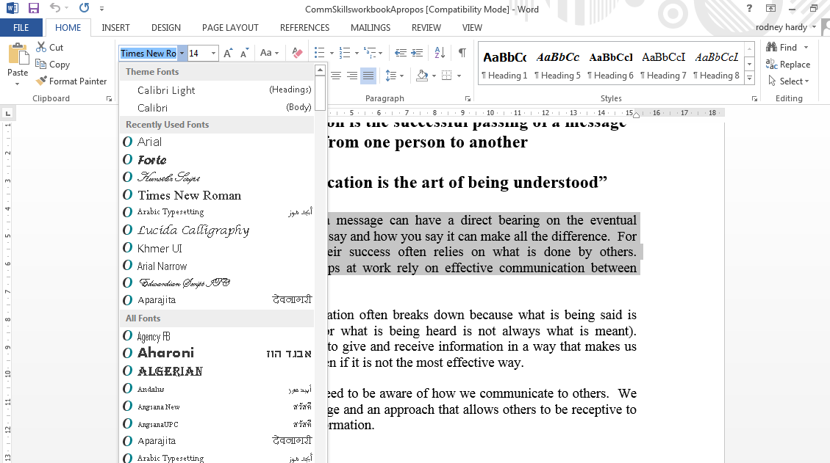

This will automatically change the required section.

If you wish to change an entire document, you must first of all remember that if you do this and save it, it will change it for everyone. Please do not do this.

If you wish to change an entire document please follow these instructions

1. Select the document you require.
2. Open a separate folder with a suitable file name.
3. Save the document into the folder.
4. 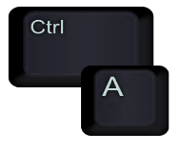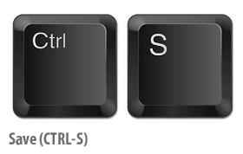To select all the text use **“Control + A”**
5. This highlights every section.
6. Use the font selection tool to select your choice.
7. Select the correct font size.
8. Check that the document has not distorted and moved text.
9. Press **“Control + S”** to save.

Sometimes it is easier to preserve this format by saving the document as a PDF

To change the **background**, or appearance of the document simply follow these instructions:

1. Select the document required.
2. Save this document into another folder with a suitable file name
3. Select the “Design” tab
4. Select the “Page Colour” option
5. Select the colour of choice to suit your learners needs
6. Press **“Control + S”** to save.

See below

