

Dyslexia Support

Using PDF Documents to read to learners

How to use a PDF document to assist anyone with reading problems

1. Open the required PDF document as below

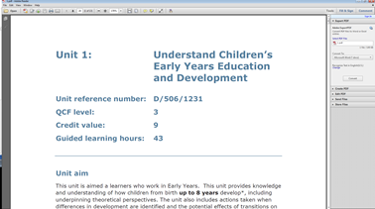

1. Ensure your laptop has speakers activated
2. Locate the “Menu” bar at the top of the page and open “View”

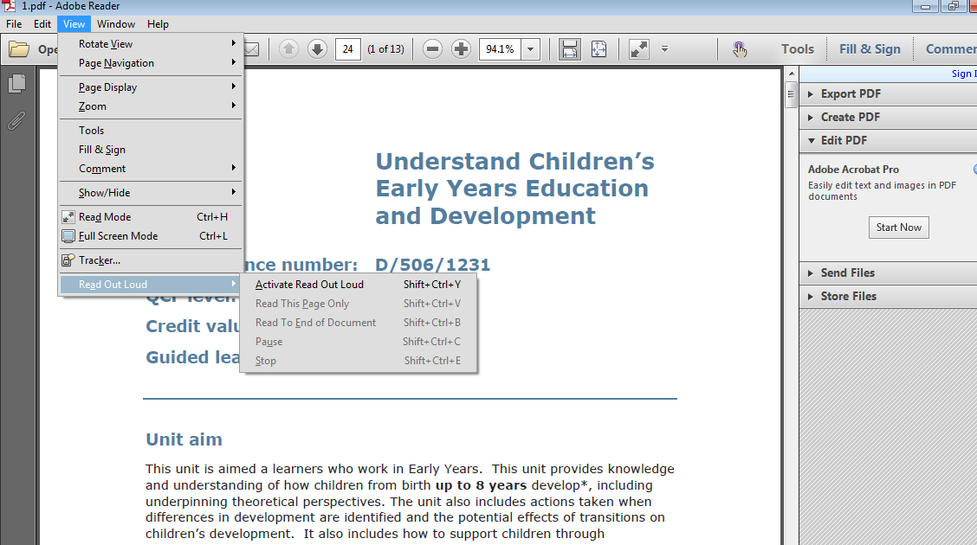

1. Select the option “Read out Loud”
2. Select the option “Activate Read out Loud”

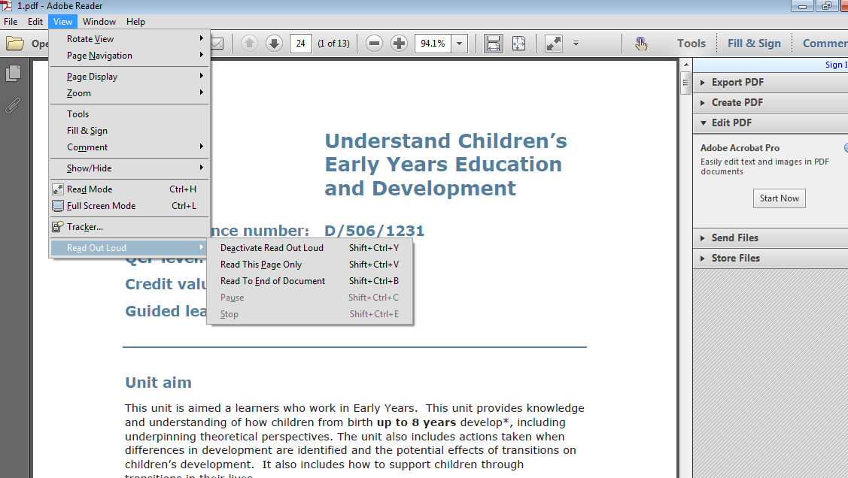

1. Highlight or click onto the areas you wish read out loud
2. Click back onto “View”
3. Select read out loud
4. Choose the appropriate option for your requirements

This may take a little time to learn properly, so please try it a few times to get used to it