# The 4 “Ws” of Privacy for Online Learning and Teaching Tools

INFORMATION PACK FOR SCHOOLS

|  |  |
| --- | --- |
|  | **WHY is privacy important for online tools?** |

People rely on and use online services every day to work, collaborate, communicate and learn - we share much about ourselves online. Understanding and educating students, staff, parents and guardians on privacy rights and how to protect them is a critical part of the schools role when providing online learning and teaching tools. Teaching students about the importance of privacy can prevent identity fraud and other crimes. Through communicating the importance of privacy to students, schools can educate them on:

➊ **APPROPRIATE USE –** ensuring that online tools are being used appropriately for learning

➋ **LIMITING SHARING –** limiting the collection of personal and sensitive information from students

➌ **BEING SAFE –** informing teachers of any concerns whenusing online tools

|  |  |
| --- | --- |
|  | **WHAT are the online  services used for?** |

Online tools used for clear learning purposes, coupled with effective teaching practice, can re-shape teaching and learning. However, there may be instances where personal or sensitive information is collected when using them.

**WHAT IS PERSONAL INFORMATION?**

* Information that can identify the individual like a name or photograph.

**WHEN IS PERSONAL INFORMATION COLLECTED?**

* To enable access to online tools provided by the Department for learning and teaching purposes.

**WHAT IS SENSITIVE INFORMATION?**

* Information, which if improperly disclosed, can have adverse consequences for an individual e.g. gender identity.

**WHY IS SENSITIVE INFORMATION COLLECTED?**

* Required as part of the school’s curriculum to complete school related assessments like social studies.

|  |  |
| --- | --- |
|  | **WHO is responsible  for privacy?** |

**DEPARTMENT**

The Department is responsible for   
**guiding** schools on applying privacy.

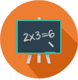**SCHOOLS**

Schools are responsible for **educating**   
staff and students on the importance of maintaining privacy.

**PARENTS OR GUARDIANS**

Parents or guardians are responsible   
for **reinforcing** the importance of privacy with their children.

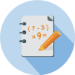**STUDENTS**

Students are responsible for **acting**   
on the privacy lessons they have   
been taught.

|  |  |
| --- | --- |
|  | WORK together with  students on privacy |
| To reinforce the importance of privacy in student’s  daily lives, remember to communicate the following:   * Only store information that you need for schoolwork. * Do not give others your username or password. * Be careful and limit what you share online. * When posting online, think:   *“Do I really need to share this information?”*   * Look after and protect your information – your privacy relies on it. * Information created and stored on online tools can be seen by school staff and online service support staff. | |

|  |  |
| --- | --- |
|  | **Example information students can safely put online** |
| * Class presentations * Conversations about classwork/assignments * School-related contact details * Class-related media i.e. videos * Whiteboard notes * Emails between classmates on school work | |
|  | |
|  | **Example information students should be careful about putting online** |
| * Health-related information * Bank details * Home address * Personal mobile or home phone number * Racial or ethnic origin * Religious beliefs or other opinions * Other student’s private information * Personal media i.e. photographs, video clips | |

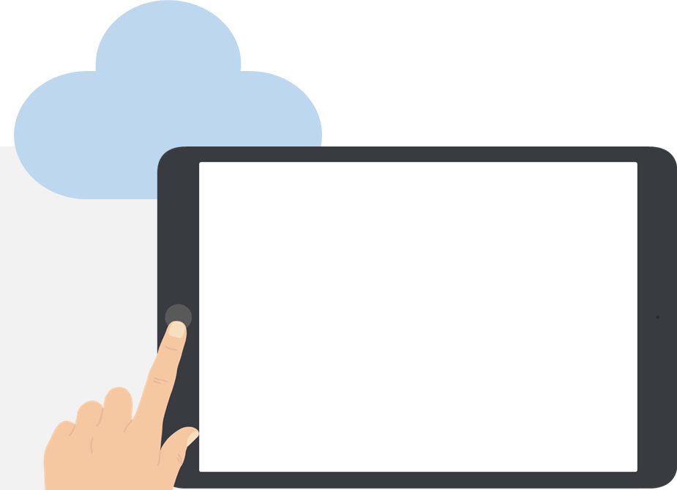

**Things for students to think about when using online tools:**

**Students have the capacity and a requirement to control the information they post online.**

* When a student makes a video, it is a requirement that everyone in that video gives permission before it’s posted online. If permission is not given or is later withdrawn, then the video needs to be taken offline.

**Systems interconnect and share information and data.**

* When signing up to a new online service it is important for students to know who is getting access to the information they provide – is it linked to another online service or social media site and is your information shared?

**Identify and manage known and unknown audiences.**

* Students need to check privacy settings on each online service, these settings control who sees their content and who can contact them.

**How to protect their own personal information and be mindful of what they share.**

* When learning online students need to be careful when publishing any personal information, such as their address or health information.

**School staff will assist students to get it right.**

**To find out more about Privacy visit:**

<http://www.education.vic.gov.au/Pages/privacy.aspx>