5 Tips on How to Teach Literacy Every Day in Early Education

Literacy is More Than Reading – It Starts the Moment Babies Hear a Voice!
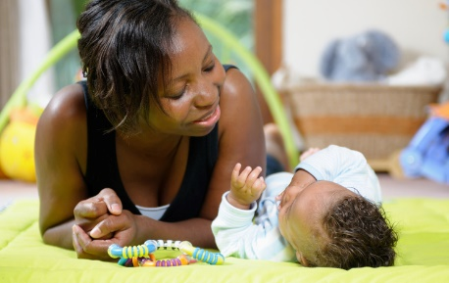
When many people think about early literacy, they think about reading. But promoting literacy includes so much more than learning to read in the early years.
Even before birth, babies start to learn language skills. They are aware of familiar voices and sounds. Literacy development begins very early in life. We know that early literacy impacts school achievement and is interrelated with all of the domains of child development. The stronger children's experiences are with language, the more likely they will experience success when learning to read.

Seven Skills That Promote Literacy

- Understanding the language and literacy development of infants, toddlers, and preschoolers
- Creating a language and literacy rich learning environment
- Supporting oral language development
- Fostering reading development
- Encouraging writing development
- Supporting dual language learners
- Partnering with families to strengthen teaching and make cultural connections

Literacy in Your Everyday Life as an Early Childhood Educator
Early educators should remember:
- That their respect for family diversity and cultures can be very important to early literacy development.
- Use multiple strategies to both teach and assess early literacy
- Introduce books to infants and read with toddlers!
- Promote children's love of literacy – of words.
- Don't forget to help children develop listening skills.
- Connect with families to support your teaching and facilitate parent-child literacy activities

Tips for Mindful Reading to Dual Language Learners and Children with Special Needs
The likelihood of an early childhood educator working with children who speak two or more languages is increasing!
Let's help children to speak, read and write in English while supporting the learning of their home language!
Infants and toddlers may learn English and their home language simultaneously. Remember:
- Their home language is the foundation for cognitive growth.
- Children and their families will feel respected and valued when their home language is acknowledged.

Make Every Word and Activity a Step Towards Literacy
Literacy is an environment-rich aspect of every child's development.1 All of these are great ways to build a foundation for literacy with young children.
- Scribbling
- Rhyming
- Syllable segmenting
- Teaching the alphabet
- Labelling all items in your classroom to encourage reading/object learning, or
- Singing
It is up to you, as the educator to select the developmentally appropriate practices per age group, development observation, and at times, engage children through activities on subjects that interest them as well. Have fun!
Source:
5 Tips on How to Teach Literacy Every Day in Early Education - Council for Professional Recognition (cdacouncil.org)

