How should mathematics be promoted within Early Years?
21ST SEPTEMBER 2016

Promoting early mathematics skills
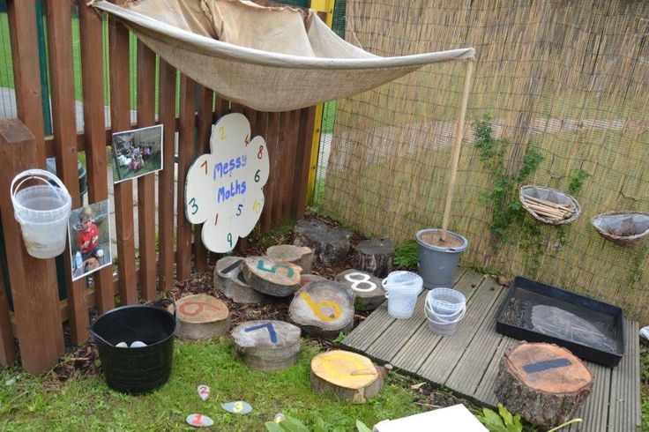Early mathematics is an important part of the Early Year’s Foundation Stage. It is down to practitioners to fully embrace this area of the EYFS and promote mathematics throughout the learning environment. As mathematics is a specific area of the EYFS, it means that it is more commonly focussed upon with children aged 3 and above, however, it is best practice that practitioners actively promote mathematics around the younger children as well as the older ones. There are various approaches that practitioners can follow to promote development in mathematics, experts have suggested some are more useful than others. Whichever method is chosen it should all be promoted through play based learning. Gaining those mathematical skills will help later on in life, and it is important that simple maths skills suggested by the EYFS are met before a child turn’s 5. With more emphasis being placed on maths skills as children become older and with the recent changes requiring all students to have a ‘C’ grade in maths it is key that these early maths skills are gained and supported.

Different approaches to promoting Mathematics
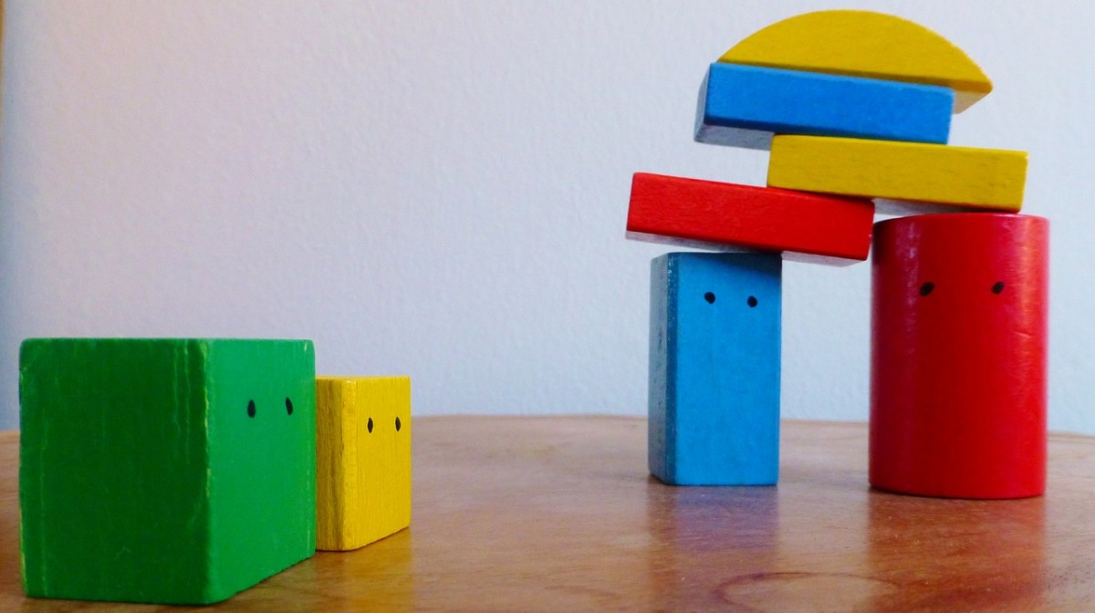 There are many different approaches taken by different practitioners to support and promote mathematical development. It is important to find the most effective approach for the individual child and ensure that each task or approach sets out achievable challenges. This ensures the child does not gain a dislike for learning maths or have their confidence damaged. It could be suggested that a varied approach to mathematical development is useful.
- Group activities – fun group learning games such as lotto or dominoes games. These encourage other skills as well promote mathematical development.
- Child led – Having the environment set up in a maths-friendly manner, so the children have lots of opportunities to discover and learn about maths for themselves. Having numbers in the environment or in messy play trays or role play areas can support this.
- Technology – There are many computer or tablet games and apps which promote early maths skills as well as development in other areas. Many children find these types of activities exciting and are often not aware they are learning maths skills.
- Practitioner interaction – Sensitive interaction from practitioners when children are playing or engaged in an activity can create lots of positive maths language and skills. Such as talking about the shapes that can be seen in the environment.
- Cooking – A great way to develop lots of maths skills as well as teach the children about healthy eating and its fun.
Experts in the early years are also urging practitioners to become more aware of the skills needed for a child to develop in mathematics and the processes a child must go through to learn to count.

The importance of the right approach
By practitioners gaining effective methods and approaches to developing early mathematical skills it can boost a child’s development by around five months, this can be more if the most effective approach is used. It’s also thought that a child who is behind in development with the correct support can catch up with their peers by the time they reach year one. This is incredibly important as research has shown children need to achieve good levels of development in all areas of the EYFS in order to thrive in later education. Some studies have shown that some children do struggle to keep up with the demands of learning mathematics during primary school, which may show the ineffectiveness of some approaches. The most effective approaches take a mixed method to learning with a variety of different learning approaches, activities, interactions and supportive resources within the environment. It may be useful during the early years wherever possible to take a more tailored approached to planning and to plan for the individual. This way the goals set can be achieved by each child.
Source
How should mathematics be promoted within Early Years? (earlyyearscareers.com)

