Early Years – Progression from Intermediate Level 2 to Advanced Level 3

Health and Safety - Advanced Studies

Understanding Risk Assessments

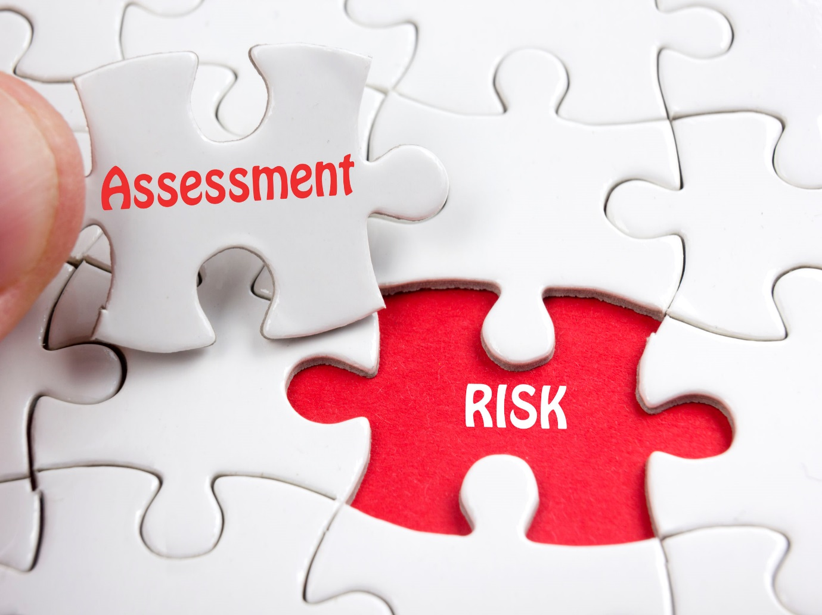

“Congratulations”

on completing your Level 2 CYPW qualification and progressing to level 3

As part of your professional development and to assist you in achieving your level 3 qualification, this support guide looks at the advanced studies you will need to develop and implement within your workplace.

Detailed below allows an insight into what is required and how you might approach this. Included are some practical examples of what you will be required to achieve

Understanding in-depth risk assessment in your setting:
Introduction

Assisting with risk assessment is an important part of your role as a practitioner working with children and young people.

We use risk assessment to help manage both health and safety and children’s welfare. Your manager and other colleagues will have overall responsibility for risk assessments.

However, they will rely on staff to help them to gather information and to recognise hazards and risks for employees, children and visitors.

This workbook will help you to understand the processes involved in risk assessment and the importance of keeping accurate records.

When do we assess risks?

In our everyday lives we assess risks all the time.

For example:

- As a pedestrian, we decide when it is safe to cross the road.

- As a motorist, we decide when it is safe to pull out at a junction.

- After a night out we decide whether it is safe to walk home, arrange a lift or use a taxi.

- We decide whether or not to smoke tobacco or take drugs.

- We decide whether to move a heavy object alone or wait for help.
Hazards and risks

In order to make risk assessments we have to recognise hazards and risks.

A hazard is defined as anything that has the potential to cause harm. A hazard may be a substance, a piece of equipment or a work procedure or, in the childcare sector, a child’s condition.

You may have thought about some of the following:

- toys and equipment

- chemical hazards, such as cleaning materials and disinfectants

- biological hazards, such as airborne and blood-borne infections

- handling and moving equipment and children

- unattended children

- security of entry points and exits

- drug and medication administration

- visual or hearing impairment of children.

Risk is defined as the chance or likelihood that harm will occur from the hazard. The
likelihood is described as ‘the expectancy of harm occurring’. It can range from ‘never’ to
‘certain’ and depends on a number of factors.

For example, the risk of someone tripping on a damaged floor surface will depend on:

- the extent of the damage

- the number of people walking over it

- the number of times they walk over it

- whether they are wearing sensible shoes

- the level of lighting.

Control measures

These are the measures or actions that are taken to remove or reduce the risk.

Whenever possible, the risk should be removed.

When it cannot be removed, measures must be taken to reduce the risk.
Health and safety risks

Health and safety risk assessment aims to identify and manage hazards that may pose a
threat to the health, safety and welfare of people or the delivery of childcare.

It involves:

- identifying a hazard

- assessing the likelihood of the hazard posing a risk

- estimating the severity of the consequences

- developing an action plan to eliminate the hazard or minimise its effect through control measures.

Risk assessment encourages managers and key staff to think about what could go wrong,
so that they can control the situation before accidents or ill health occur. By law, formal risk assessments must be carried out in every workplace.

The risk assessors are usually specially trained, competent senior managers or supervisors who are familiar with the task being assessed and safety controls. They must also be up to date with relevant legal requirements.

There are a number of stages in carrying out a risk assessment. The people involved need
to find answers to the following questions.

What are the hazards?
Look for the hazards. The workplace, the children and the activities carried out in the workplace need to be carefully examined.

Who is at risk?
Decide who might be harmed and how. Everyone or only certain people may be at risk.

Some groups of people may need special consideration, as they may be more
vulnerable to certain hazards.

What is the likelihood of injury or harm?
A hazard that is very likely to cause injury or harm will need remedying before one
that is very unlikely to do so.

What are the consequences of injury or harm?
The consequences could range from ‘minor ’ to ‘severe’ or even fatal – for example, from
a scratch to death. The most severe hazards need the most urgent attention. Decide
whether the existing precautions are adequate or whether more should be done.

It is important to record your findings and to review your assessment and revise it if
necessary.

A review must always take place when situations change – such as the introduction of new equipment, a change in use of a room, or a child with SEND requirements starting at your workplace. You must also audit control measures regularly to ensure that they are working correctly.
During your time studying for you level two qualification, you will have been involved in capturing data for risk assessment

Part of your developing role will have been to understand risks, hazards and how to overcome these. As a level 3 practitioner, responsible for the health and safety and well-being of children, your skills within this particular area must be enhanced to see beyond the visible aspects of risk assessment.

Detailed below is a comprehensive template that will encompass new areas for consideration by you.

Take time to study this and to complete it with your thoughts and recommended actions.

Completion and discussion of this with your allocated TLC will allow assessment of areas within the following learning outcomes

Unit 7: Promote the Health, Safety and Well-being of Children in Early Years Settings

Learning outcome: 1 Understand health and safety legislation and regulations

Learning Outcome: 4 Understand how to keep children safe and secure in early years settings

Learning Outcome: 5 Understand how to respond to accidents and emergency situations

Learning Outcome: 7 Understand how to assess health and safety risks in early years settings

Learning Outcome: 8 Understand how to maintain records and reports
Health and Safety: Risk Assessment For: << enter name of nursery >>

Setting the scene - Example  The manager carried out the risk assessment in this nursery, which is located on a suburban residential estate.  The nursery caters for 20 children aging from 6 months to 11 years of age.  The manager is a full-time member of staff, as is the deputy manager who provides cover for the manager.  Both the manager and the assistant manager are appointed persons for first aid.  There are ten other staff members, a mixture of part and full time staff and some students on work placement and apprentices  Most staff are practitioners however there is also a cook and a part-time maintenance operative |  |  | How was the risk assessment done?  The manager followed the guidance in five steps to risk assessment.  1. To identify the hazards, the manager:  (a) walked around the nursery and all other areas, noting things that might pose a risk and taking into consideration what they’d learnt from training They also took occasional activities, such as changing displays or light bulbs, into account;  (b) talked to members of staff to listen to their concerns and opinions about health and safety issues in the nursery; and looked at the accident book, to understand what previous problems had occurred.  2. The manager then wrote down who could be harmed by the hazards and how.  3. For each hazard, the manager wrote down what controls, if any, were in place to manage these hazards. Where they didn’t consider existing controls good enough, the manager wrote down what else needed to be done to control the risk.  4. The manager discussed the findings with staff and pinned a copy of the risk assessment up in the staff room. They put the risk assessment into practice, making sure that each identified action was done and ticking each one off as it was completed. They also decided to make it part of the induction process for new staff.  5. The manager decided to review and update the risk assessment every year or straightaway if any major changes in the workplace happened.
What are the hazards? | Who might be harmed and how? | What are you already doing? |  | What further  action is  necessary? | Action by  Whom? | Action by  When? |  | Done
Slips and Trips |  |  |  |  |  |  |  | Date
 |  |  |  |  |  |  |  | Date
Manual Handling |  |  |  |  |  |  |  | Date
What are the hazards? | Who might be harmed and how? | What are you already doing? |  | What further  action is necessary? | Action by  Whom? | Action by  When? |  | Done
Musculoskeletal

Work at Height
Appropriate
access
equipment e.g.
kick stool or
small steps are
provided to
reach high
shelves

Security

How do we control access to the nursery?

How do we protect children when playing outside the nursery?

How do we inspect the outside environment?

What are the hazards? | Who might be harmed and how? | What are you already doing? | What further  action is  necessary? | Action by  Whom? | Action by  When? | Done
Electrical

What are the hazards? | Who might be harmed and how? | What are you already doing? | What further  action is  necessary? | Action by  Whom? | Action by  When? | Done
Play Equipment (indoors)

Play Equipment (outdoors)

Glass windows and doors

What are the hazards? | Who might be harmed and how? | What are you already doing? | What further  action is  necessary? | Action by  Whom? | Action by  When? | Done
Doors – Internal and External

Educational Visits

Contractors

What are the hazards? | Who might be harmed and how? | What are you already doing? | What further  action is  necessary? | Action by  Whom? | Action by  When? | Done
COSHH

What are the hazards? | Who might be harmed and how? | What are you already doing? | What further  action is  necessary? | Action by  Whom? | Action by  When? | Done
Allergies

Choking Hazards

Risk assessment Number: _______

Site: _________________________________________________________________________

Carried out by: ___________________________________________ Date:

Mangers Signature: _______________________________________ Date:

ëAny other comments

