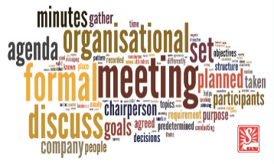
Formal meetings
A formal meeting is a pre-planned gathering of two or more people who have assembled for the purpose of achieving a common goal through verbal interaction. Formal meetings are characterised by their predetermined topics, a set of objectives and formal notices. These meetings are held at a specific time, at a defined place and according to an agreed agenda. Formal meetings are typically lead by a chairperson with the discussions and agreements recorded in a written form known as minutes.
What’s involved with a formal meeting?
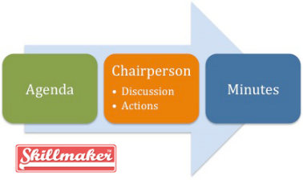
Many formal meetings follow a set pattern. This helps to give the meeting an organised structure. This pattern is usually set out in an agenda, which is circulated to participants in advance, along with a copy of the minutes from the last meeting. At the beginning of a meeting, participants will agree to the accuracy of the minutes from the last meeting. Attendees will give updates on any action items from the previous meeting. The items on the agenda will then be discussed. Minutes (official notes) will be taken throughout the meeting. There often has to be a certain number of people present for the members to be able to conduct valid business.

Informal meetings
An informal meeting is a meeting which is far less heavily planned and regulated than a formal business meeting, and so lacks many of the defining features of a formal business meeting, such as minutes, a chairperson and a set agenda. These informal meetings are far more likely to take place in a casual setting, such as a restaurant or a coffee shop, or at one of the participant’s desks, rather than take place in a boardroom.

What’s involved with informal meetings?
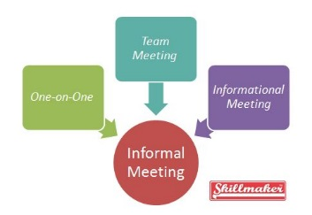
There are no formal requirements for informal meetings, which is why they are easier to arrange than formal ones. More things can be discussed in informal meetings, because there is not a requirement to stick to a formal agenda. However, some decisions cannot be taken at informal meetings, because they must be put to a larger group of people at a formal meeting, due to legal restrictions.
The purpose of an informal meeting is to discuss issues which would not have an appropriate place in a formal meeting. They may be designed to make one of the participants feel more at ease and more free to speak their mind than they would in a more formal setting. They allow participants to meet with a greater degree of spontaneity and flexibility.

Responsibilities of the Chairperson before the meeting
- Schedules meeting; Prepares the agenda; Clarifies roles and responsibilities
Responsibilities of the Chairperson during the meeting:
- Start the meeting on time
- Clarify roles and responsibilities
- Establish ground rules and guidelines
- Participate as a team member
- Follow the agenda and keeps the meeting focused on agenda items
- Retain the power to stop what’s happening and change the format
- Push for accountability
- Summarise key decisions and actions
- Record recommendations and allocate responsibilities for specific tasks
- Make the most of talent present - ask questions to draw out people with talent and experience
- Allow time to hear experts’ (if present) points of view but allocate time with clear directions, for example, "We have five minutes to hear the technical reasons why we should support this”.
For important issues when time is limited set up a sub-committee to collect facts, review the situation, and prepare recommendations to be considered at the next meeting.
- Close the meeting on time and on a positive, appreciative and graceful note.

Responsibilities of the Minute Taker
A minute taker is the attendee at meeting whose role it is to record the minutes of the meeting. The note taker may be a formal, professional note taker, whose only job is to take notes, or they may be an active participant in the meeting who has taken on the role for that specific meeting.
The minute taker must keep an accurate record of what happened at the meeting and what decisions were made. They must take notes in an impartial way and they must not try to impose their own opinions into the notes which have been taken. The minute taker must prepare and distribute a formal version of their notes as soon as possible after the meeting is over. They must distribute their formal minutes in good time before the next meeting, so that attendees will have chance to consider them.

Meeting Participants
These individuals are the active participants during a meeting. They are the ones called for to attend a meeting. As stated earlier, the attendees of a certain type of meeting are selected individuals and are called for by invitation. They join a meeting in response to a meeting request sent out by the facilitator or meeting organizer.
They are expected to interact actively in activities.

